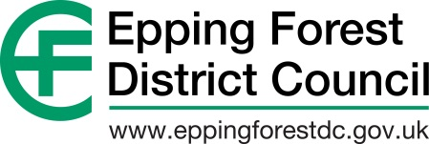
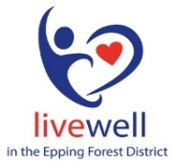

Epping Forest Compact
What is a Compact?

A Compact is a written understanding between the Statutory and Voluntary and Community Sectors. It defines how the two sectors behave toward each other. It is an agreement between organisations, not individuals, designed to benefit the local community, by establishing an effective relationship between the two sectors and ensuring that energies and resources are not wasted and more joint working is possible. Compacts are not legally binding documents. Their authority comes from the fact that they are developed, consulted upon and formally adopted by local stakeholders themselves.

Background of the Compact

The Voluntary and Community Sector is central to a democratic, socially inclusive society. The services provided by the sector complement local authority provision and are part of a whole package of quality services available to the community. Voluntary and community organisations make a vast contribution to the social, cultural and economic life in the Epping Forest District and beyond. They act as pathfinders for the involvement of users in the design and delivery of services and often act as advocates for those who otherwise have no voice. In doing so, they promote equality and diversity. They help to alleviate poverty, improve the quality of life and empower socially excluded people. The Voluntary and Community Sector can operate most effectively if it has the understanding and support of the Statutory Sector, and vice versa.

Epping Forest Compact Member Registration Slip

Please complete the Compact Member registration slip to confirm your organisation understands and agrees with the content of the Compact and will adhere to the recommendations detailed within. Keep a copy for your records and email a signed copy to grantaid@eppingforestdc.gov.uk to be added to the register of members.
Name of Organisation:
Name of Individual signing on behalf of Organisation:

Role within the Organisation:

Signature:

Date:

