ONG-EF105

Ongar Neighbourhood Plan Statement of Engagement

Introduction

The Neighbourhood Planning (General) Regulations 2012 Section 15(2) of Part 5 (Localism Act 2011)
requires a Consultation Statement to set out the consultations undertaken for the Neighbourhood
Plan. This Consultation Statement supports the Ongar Neighbourhood Plan (ONP) and contains the following:
a) Details of people and organisations consulted about the proposed Neighbourhood Plan (NP)
b) Details of how they were consulted
c) A summary of the main issues and concerns raised through the consultation process
d) Descriptions of how these issues and concerns have been considered and addressed in the proposed NP
The preparation of the ONP has involved residents, businesses and other organisations with an
interest in the plan area.

This Statement sets out details of events and consultations and the ongoing work of the committee of the Ongar Neighbourhood Plan Community Group (ONPCG). The aim of the consultations has been to ensure that there is a widespread understanding of the reasons for and content of the ONP. It has also been important to demonstrate to the community that the issues they have raised have been listened to.

Neighbourhood Plans must meet a number of ‘basic conditions’ set out
in Schedule 4B of the Town and Country Planning Act 1990, and Neighbourhood Plans must
also have regard to national planning policy as well as be in general conformity with the
strategic policies of the District Council’s Local Plan. Officers in EFDC Council’s Planning Policy
Team have met ONPCG several times and reviewed the Draft Ongar Neighbourhood Plan in various stages, commenting accordingly. (see also Consultation Responses and Comments ) EFDC has confirmed that an SEA or an HRA is not required.

Background

Ongar Town Council (OTC) as the authorising body set up a Working Party for a Neighbourhood Plan in spring 2017. The Steering Group -Ongar Neighbourhood Plan Community Group was set up following a successful public meeting on 3rd July 2017 attended by over 60 interested stakeholders.

ONPCG met regularly from 6th September 2017 with open meetings. Topic Subgroups were formed Initial brainstorming and SWOT analysis included a workshop and at various local events such as at the Annual Town Meeting and Annual School Fete carried out.

Research and background analysis of the Neighbourhood got underway and the ONPCG made Representations at the Local Plan Public Enquiry in 2018 on various aspects including proposed allocated residential sites in the civil parish of Ongar.

Consultations about the Neighbourhood Plan include local residents and businesses and various government bodies and organisations, from 2018.
ONPCG promoted the producing of a Neighbourhood Plan reached out widely within the community for involvement through articles in Ongar News, specific advertising of events, banners in the town, stalls at local events. ONPCG commissioned banners to promote the NP at events and set up a website and Facebook page.

Our main Consultation event was a two day exhibition in October 2018.

Other Consultations with local residents and businesses took the form of
- Talks and Questions and Answer sessions to specific organisations, Schools, Businesses, or their representatives, including:
  - Local History Group – Ongar Millennium Historic Society(OMHS)
  - Local Wildlife Group- Ongar Wild Life Society (OWLS)
  - Ongar Mums Group
  - Ongar Sports Club
  - Ongar Netball Club
  - Ongar Academy Student Council
  - Marden Ash Action Group
  - Chipping Ongar Primary School
  - Ongar Academy
  - Ongar Town Council Annual Town Meeting (2018 and 2019)
  - Ongar Business Group
  - Ongar in Bloom
  - Ongar Round Table
  - Rotary Club of Ongar
- Local Residents Associations were invited to and attended our meetings from time to time, including:
  - Marden Ash Action Group
  - Greensted residents group
  - Ongar action group
  - Bowes field action group
  - Shelley residents association
- Surveys including:
Towards the beginning of the process a number of glad/sad boards and SWOT were conducted at local events and a workshop held with OTC councillors

ONPCG had consultations about the NP – by letter, phone and face to face-with a variety of specialist departments or organisations including (but not exclusively):
- EFDC including (but not exclusively):
  - Planning Department
  - Historic Environment
  - Economic Growth
  - Leisure facilities
- ECC including (but not exclusively)
  - Education department (future capacity within schools)
  - Pre-school provision
  - Highways- re solutions to reduce through traffic in the High St especially HGVs
  - Place Services- re historic environment
- Ongar Health Centre
- Sport England
- Historic England
- CPRE
- Community Land Trusts
- RCCE
- Essex Police

Types of Engagement

The following give more detail of some of the events listed above

Local events
Surveys
Websites
Social media
Discussions with local businesses and stakeholders
Regulation 14 responses
Consultants / Professional advice
Regular articles in Ongar News
Banners on Epping Ongar Railway railings and Ongar Bridge Motors railings
Posters in shops, hospitality and cultural venues advertising events

Local Events

  - Ongar Town Festival 2018

ONPCG had a stall at the Ongar Town Festival from 05 May 2018 to 06 May 2018 with the purpose of
- raising awareness of the development proposals for Ongar in EFDC draft Local Plan
- raising awareness of how a Neighbourhood Plan could influence future land use
- collating local opinion on the above of those attending and
- to set expectations around what would not be possible.
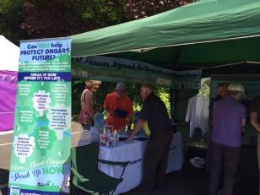
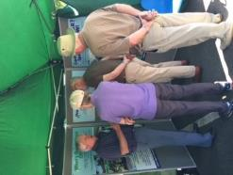

A survey was also conducted about Town Centre use with results below .
There was also a competition to spot local sites within the town centre

  - Ongar Primary School Fetes 2017 and 2018

In 2017 OTC’s Working Party on Neighbourhood planning had a stall which, in addition to an activity for children (guess the number of sweets in a jar) also had a glad/sad board for people to add comments about Ongar. This was useful in gauging the interest in producing a Neighbourhood Plan and prior to the initial public meeting at the Budworth Hall on 3rd July 2017.
ONPCG had a stall at the Ongar Primary School Fete on 24 June 2018 with the purpose of
- raising awareness of the development proposals for Ongar in EFDC draft Local Plan
- raising awareness of how a Neighbourhood Plan could influence future land use
- collating local opinion on the above of those attending and
- to set expectations around what would not be possible.
A survey was conducted about family life and requirements for the future

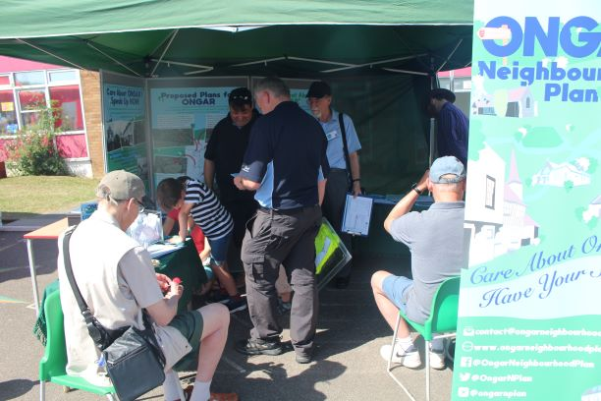

4.3 Initial Public Meeting 2017

Ongar Neighbourhood Plan Community Group (ONPCG) was set up by members of OTC’s Working Party on Neighbourhood Plan and included several Ongar Town Councillors local Chartered Town Planner. An Initial public meeting was held on the 03 July 2017 at Budworth Hall in Ongar, advertised with posters in various shops, to determine the level of interest and support in producing a Neighbourhood Plan for Ongar. An initial presentation was made by Phil Bowden of Navigus Planning and a Question and Answer session followed. Over 60 people attended and a committee was set up and work began.
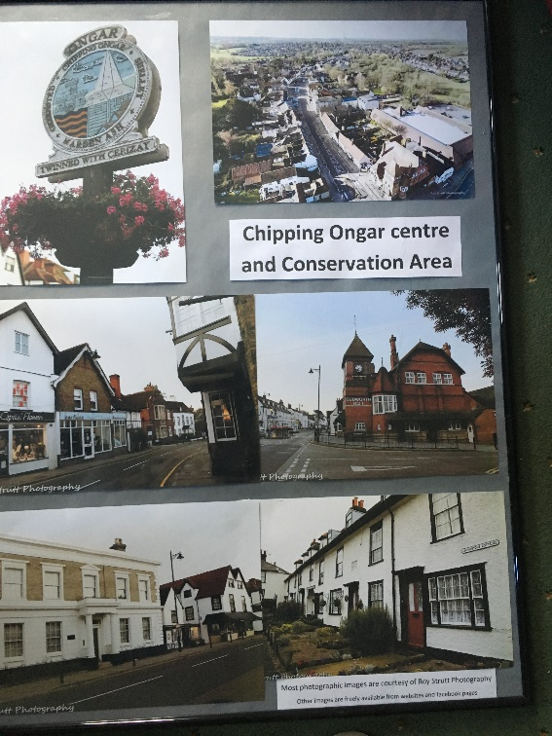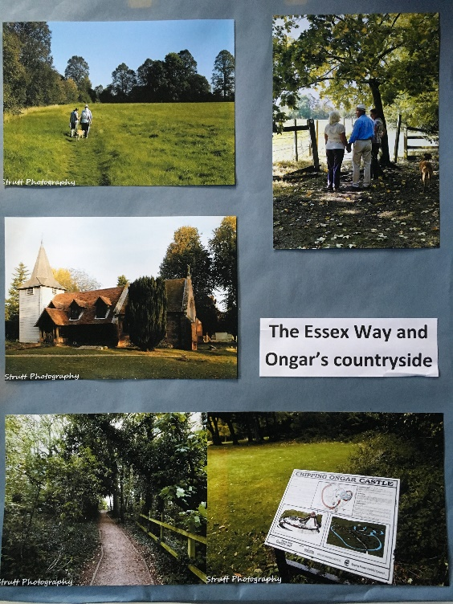

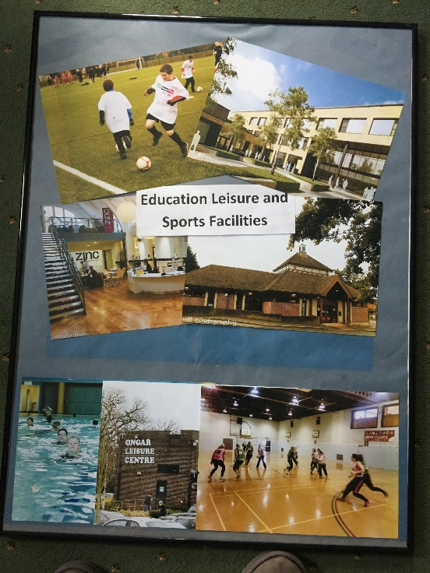
After a few set backs, work began in earnest in 2018. ONPCG was approved and appointed by OTC to produce a Neighbourhood Plan on its behalf, but was not directly a council committee so retained some independence, but reported back regularly. ONPCG committee members had discussions and meetings with various local organisations, schools, various bodies involved in planning issues and other interested parties. ONPCG also made representation at the public enquiry stage of the Local Plan. ONPCG made presentations at various local events in 2018 and 2019

4.4 Budworth Hall Drop in Session Two Day Exhibition and Consultation October 2018

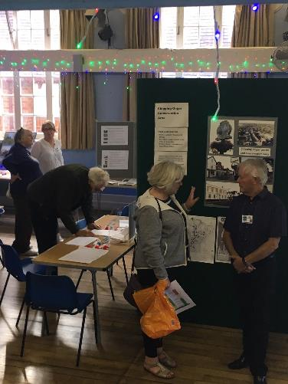
The main public event was held by Ongar Neighbourhood Plan Group on Friday 12th and Saturday 13th October 2018 at the centrally placed Budworth Hall. The large exhibition and drop in session was well attended with over 600 people registering. Flyers were distributed throughout the town and posters displayed Appendix 1.
The purpose was to provide information about
- what a Neighbourhood Plan could achieve with examples from other Neighbourhood Plans, but setting expectations around what would not be possible
- display information about our area;
- collate the ideas, views and opinions of those attending to inform forthcoming policies and rationale;
All members were on hand to provide information, as well as Sarah Sapsford from RCCE and Tai Tsui from EFDC Planning Department
The exhibition included a number of large free standing exhibition stands as well as table display boards:
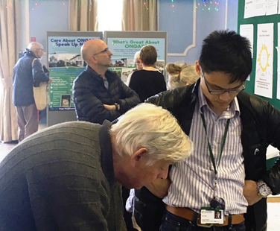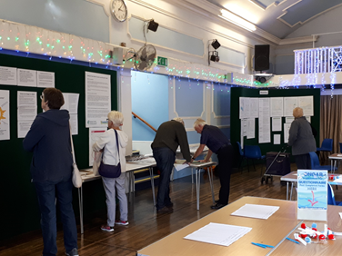

- Displays of locations of EFDC allocated housing sites in Ongar for approx. 600 more homes;
- information about EFDC ‘Infrastructure Delivery Schedule’; and its ‘Strategic Policies’
- Information and displays about Ongar’s natural environment, our historic heritage and our sports facilities
- Designs for new housing suggested by Essex County Council’s Design Guide
- Recommendations from documents by Historic England
- Local statistics from data from the Office for National Statistics, Essex County Council and Epping Forest District Council

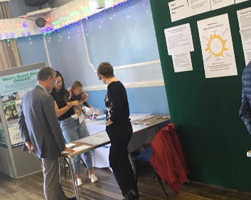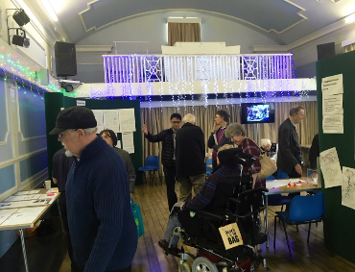

In order to gauge opinions the attendees were asked to complete questionnaires and surveys.
The Generic Housing Questionnaire is Appendix 2 with results can be seen in Appendix 3.
Free form questions included what they considered to be good design ideas on Post-it notes, please see Appendix 4 and Appendix 5.
The results of the Town Centre Questionnaire can be seen in Appendix 6.
The event was well attended by local people, developers and Council members. The policies now included in the Neighbourhood Plan reflect priorities, concerns and feedback from the local residents at this and other engagement events. The best example of this can be seen in Appendix 2 and 3 Housing Survey and responses.

Presentation and Question and Answers at Ongar Town Council Annual Town Meetings (ATM) 2018 and 2019
There were also ‘glad/sad’ boards at the 2018 ATM in addition to power point presentations and display boards and banners.

ONPCG Surveys and Key Findings
The main Residents Survey took place in early 2019 and was publicised in Ongar News, Ongar Town Council boards and website and social media. The printed Surveys were delivered by Ongar Town Councillors to all households in the civil parish. There were 7 drop off points for completed questionnaires

Background
Ongar Neighbourhood Plan Community Group (ONPCG) has undertaken a number of surveys of local opinion that have been used to inform Ongar Neighbourhood Plan (ONP) draft Policies.
  - Town Centre Survey- at 2018 Town Festival
  - Family Survey -at Annual School Fete 2018
  - Several at the 2 day Exhibition in Budworth Hall Oct 2018 on including
    - Housing
    - Historic centre
    - Sports and recreation
    - Youth
    - Natural environment
  - Youth Survey-all pupils at Ongar Academy in 2019
  - Residents Survey Feb 2019- delivered to all households in the civil parish

Key Findings

Town Centre
Most people visit the town centre for Shops, Service and restaurants.
73% of respondents believed that the pavements were not wide enough and 65% that there were insufficient crossings.
67% would not feel safe cycling in the High Street

Housing
Most popular reasons for moving to Ongar, the Green Belt protected against development, the Green and Open spaces and view of the countryside.
Future developments should include green and open spaces with trees and verges, footpaths with access to countryside and town centre, sports and play areas. The natural habitat of wildlife should be maintained.
Detached and Semi detached bungalows were favoured for future developments. More than half disapproved of and 87% agreed new homes should have a maximum of two storeys high (but permitting dormers in roofs).

Youth
Approaching half of respondents cycle. 29% use Jubilee Park and 32% use Ongar Leisure Centre weekly or more often. 30% use footpaths, bridleways and cycleways in the countryside weekly or more often. Most needed in Ongar was a Youth Café with free wifi (48%) and a climbing wall (39%).

Residents Survey

SECTION 1 – Ongar today and next 15 Years
Respondents believe that Ongar is friendly, has good access to the countryside and that the historic town centre adds character. It is important that children can walk to school. Transport in Ongar is not good. Additional facilities and amenities will be needed as Ongar’s population grows.

SECTION 2 – Housing
Respondents believe that future developments should include semi detached residences of 2 or 3 bedrooms. Bungalows featured heavily with a maximum of two storey buildings. Development should reflect the density of the neighbouring residences. There should be sufficient off road parking for the number of bedrooms. Affordable housing should be offered to those with an Ongar connection first. Also see Housing Survey as results were closely aligned.

SECTION 3 – Education
Over half of respondents that use primary schools in Ongar walk and for secondary schools 79% walk.

SECTION 4 – Transport and getting around
There is an even split between walking and motorised transport for those travelling within Ongar. Most respondents park their car(s) on their drive. Of working respondent the most popular location was London. Most car commuters were put off using public transport because public transport was too infrequent or did not go to the place they needed to go. With more homes in Ongar respondents believed that the number and speed of HGVs should be reduced, a cheap non stop commuter bus and improved traffic safety measures around schools are all important . More parking in the town and at the health centre are required. Poorly maintained pavements and vehicular obstructions are the greatest challenges when getting around Ongar for those with a mobility issue

SECTION 5 – Historic Town Centre, Local Economy and Tourism
More varied food shops or farmers market’ and ‘Drop in centre for the elderly’ in or close to the High Street would help benefit Ongar as a vibrant centre. Historic buildings and view should be protected. Historic materials should be used in the town centre to improve attractiveness. Car parking should be improved.

SECTION 6 – Sports and Leisure facilities
‘Footpaths & bridleways around Ongar’ and ‘Library’ are the most used facilities amongst respondents. ‘More playing areas, recreation ground’ and ‘More children’s play equipment’ were seen as the most needed additional sports facilities as Ongar is developed. If Ongar leisure centre closed most people would not travel to use the swimming pool.

SECTION 7 – Natural Environment Protection
Ongar and Greensted Woods should be protected ’ and ‘Ancient and veteran trees and hedges in the Ongar area should be protected’ to maintain the rural setting and protect the natural environment and its biodiversity.

SECTION 8 – Youth Voice
Amongst under 18s ‘ Cycle paths/ Bridleways/ Footpaths in the countryside ‘ and ‘Ongar swimming pool’ were most commonly used. Also see results of Youth Survey

Websites

Ongar Town Council
http://www.ongartowncouncil.gov.uk/

Ongar Neighbourhood Plan
https://www.ongarneighbourhoodplan.uk/

Social Media

Twitter
https://twitter.com/OngarNPlan

Facebook
https://www.facebook.com/groups/Ongarhaveyoursay/

Discussions with local residents, businesses and stakeholders

A number of local stakeholders were consulted during the Neighbourhood Plan preparation to ensure input was gathered from across the demographic of Ongar as well as businesses, local interest and activity groups, Local Government bodies and departments. The list below provides details:-
- Workshops with
  - Ongar Town Council (OTC) including SWOT analysis
  - Ongar Academy Pupils (School Council)

- Regular update meetings with OTC

- Presentations at
  - Ongar Wildlife Society (OWLS),
  - Ongar Millennium History Society (OMHS) and
  - Ongar Business Group (now defunct)

- Discussions, meetings etc with various local groups and individuals etc including:-

  - Ongar Mums Group;
  - Marden Ash Residents group;
  - Greensted Rd residents group;
  - Ongar Action Group;
  - Residents group adjacent to Bowes Field;
  - Local landowners and agents;
  - Local Estate Agents
  - Essex County Council (ECC) Education department;
  - Epping Forest District Council (EFDC) Economic Growth department;
  - ECC Highways department;
  - EFDC sports and Leisure dept;
  - Ongar Town Forum;
  - Ongar Academy;
  - Ongar Primary School;
  - Pre-school Groups;
  - Ongar Sports Club;
  - PfP management (re Ongar Leisure Centre);
  - EFDC Housing Dept;
  - Ongar in Bloom;
  - Rotary Club of Ongar;
  - Ongar Round Table.
  - Local Historians
  - Ongar Health Centre
  - Ongar Town Forum
  - Chipping Ongar Town Centre businesses, including retail, services and hospitality
  - Clergy and committee members representing local churches

Progress updates provided in regular articles featured in the Ongar News and occasionally in other published media e.g Vision and Essex Life and social media (mainly Facebook) .

Consultants
During the preparation of the Neighbourhood Plan the following consultants / professional bodies were used.

Consultant / Body | Key Activity
Urban Vision Enterprise CIC | Policy drafting, evidence and legal process advice
Navigus Planning | Initial advice and structure for a NP
RCCE | Support throughout on all aspects of the process, community engagement, surveys, other NPs as examples
EFDC: Historic Environment, Economic Growth, and Planning Officers | Help to ensure ONP applies more detail than a Local plan and is not in conflict with the EFDC new Local Plan. Planning Officers gave advice throughout
ECC: Education, Planning, Historic Environment & Highways Officers | Meeting education needs; policies to enhance NPPF and Local Plan policies on historic environment; possible solutions to traffic management and parking
Essex Police | Planning to reduce crime and anti-social behaviour
Sport England | Meeting infrastructure needs in recreation and sports
RTPI & Chartered Town Planners | Advice on various aspects
Ongar Health Centre | Meeting health needs of increased population
CPRE | Protecting our natural environment and rural identity
Local Historians | Background knowledge of the civil parish
Local landowners | Rural diversification and farming needs
Local MP | Confirming and providing finer detail of Government policies in various aspects affecting NPs and Planning

Regulation 14 Consultation
Regulation 14 Version of ONP had its 6 week consultation from 21st January 2021 until 18th March 2021, during lockdown for Covid-19. Methods of promoting the consultation widely yet within the lockdown restrictions were agreed with various bodies including RCCE.
Feedback was received from members of the public and the statutory consultees. For more details see evidence file ONG-EF106 Consultation Statement
In 2021, UK Government issued an updated NPPF July 2021 and National Design Guide and in July 2021 issued a National Model Design Code. Also the Building Beautiful Building Better commission issued its report Building with Beauty in late 2020. References to these documents have been included in the Submission Version of Ongar Neighbourhood Plan.
In the light of the feedback received a number of minor amendments were made to the Policy wording and the Rationale/Justifications were strengthened accordingly to the responses particularly from EFDC. ECC, Historic England and the Environment Agency also requested inclusion of additional Policies. In most cases ONPCG was advised that National and District Level Policies would suffice and that Ongar did not have a case for different or reinforced Policies in those areas. Other possible additional inclusions will be considered when this Neighbourhood Plan is due for revision in a few years time.
See Consultation Statement for more information.
Details of specific feedback and our comments and actions are in the following documents. We consulted our Chartered Town Planner and Urban Designer Dave Chetwyn and are confidents that these are only minor changes and therefore do not require a repeat of Regulation 14 Consultation.

Regular articles in Ongar News
Updates of progress were provided in regular articles in the free monthly Ongar News (distribution approximately 2000. Ongar News is also now on Facebook

Banners
Long banners advertising Ongar Neighbourhood Plan events and the exhibition at Budworth Hall in 2018 were displayed on railings at Epping Ongar Railway station and Ongar Bridge Motors. Both border the High Street at the northern and southern parts respectively

Posters and Drop Off points for questionnaires and competitions.
Approximately a dozen shops, hospitality and community venues posted Posters advertising events and also providing collection post boxes for the Residents Survey and also for Competitions This included Ongar Leisure Centre, Zinc Arts, Ongar Library, Sears Estate Agent, Senners newsagents, Kings Head, Hockings butcher, Bubbles pet shop

Appendix 1 Budworth Hall Event Posters

Appendix 2 Housing questionnaire at the Budworth Hall Event

Appendix 3 Housing and related questionnaire and responses from Budworth Hall Event

Appendix 4 Design Responses from Budworth Hall Event

Appendix 6 Various questionnaires and responses from from Budworth Hall Event

Appendix 8_Initial Public Meeting Poster and display boards

Appendix 9 Selection of display material and banners

Appendix 10 Selection of questionnaires used at other events

Aerial view of the civil parish

End

